PROJECT DEMONSTRATION PHASE
Project Title
Streamlining IT Procurement: Automating Standard Laptop Orders with Flow Designer

1. Demonstration Objective
The demonstration is used to show the complete working of the automated Standard Laptop procurement process in ServiceNow.
It demonstrates how a Standard Laptop request is placed, approved and processed through the automated Flow.

2. Demonstration Steps
Step 1 – Open Service Catalog
- Open ServiceNow.
- Click All.
- Search for Service Catalog.
- Open Service Catalog.
- Click Hardware.
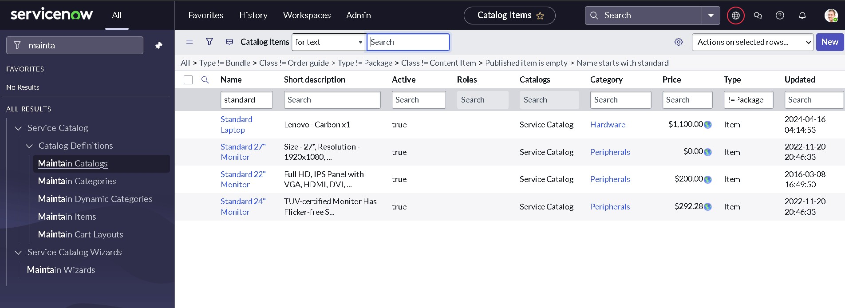

Step 2 – Select Standard Laptop
- Find Standard Laptop.
- Select Standard Laptop.
- Click Order Now to place the request.
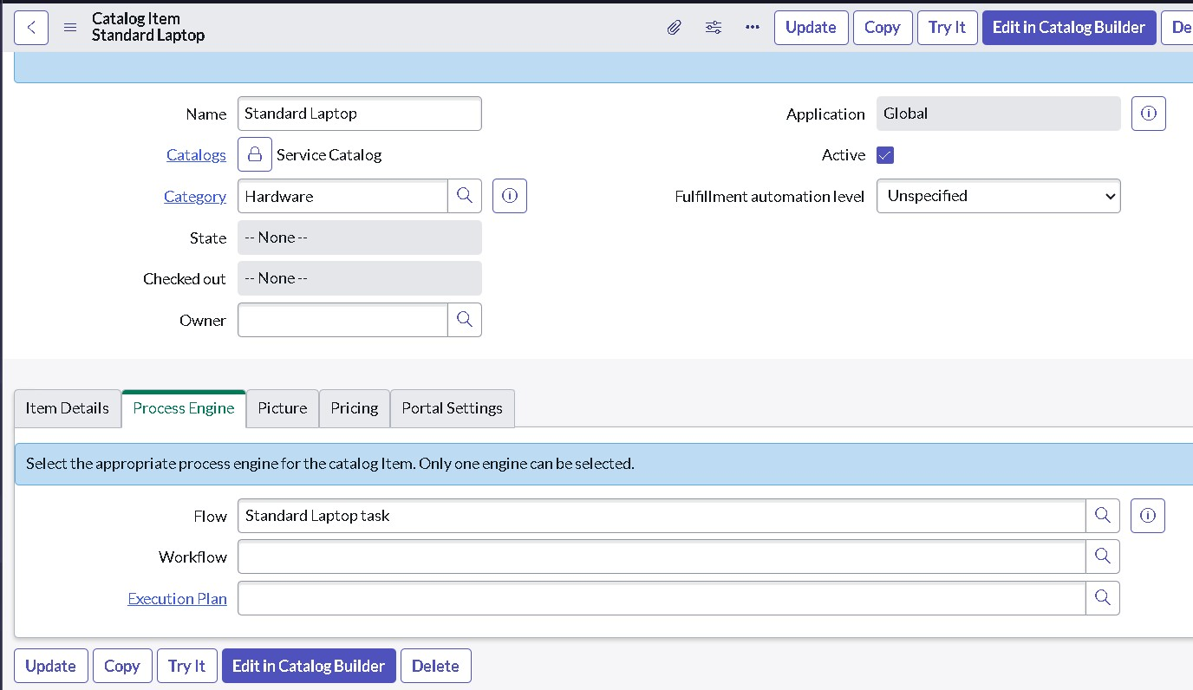

Step 3 – Check Order Status
- Check the Order Status.
- Click on the Request Number.
- The Requested Number record will open.
- Scroll down to the Approvers section.
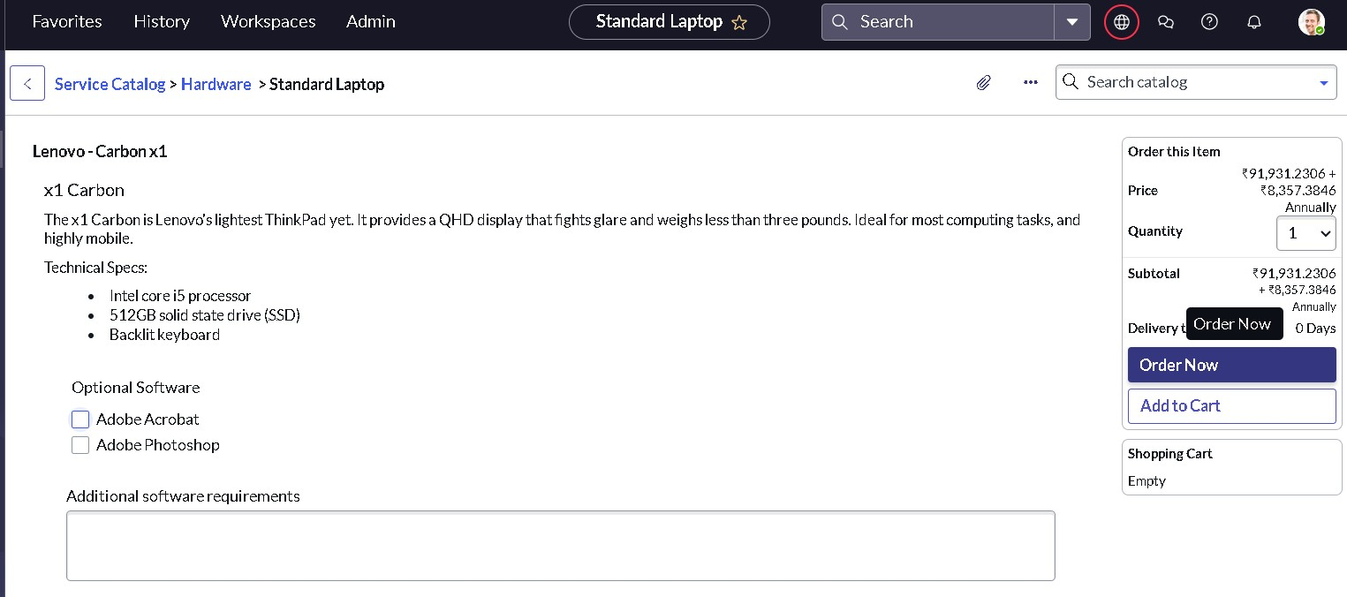

Step 4 – Approve the Request
- Right-click on the record.
- Click Approve.
- Click the Requested Item section.
- Open the Requested Item record.
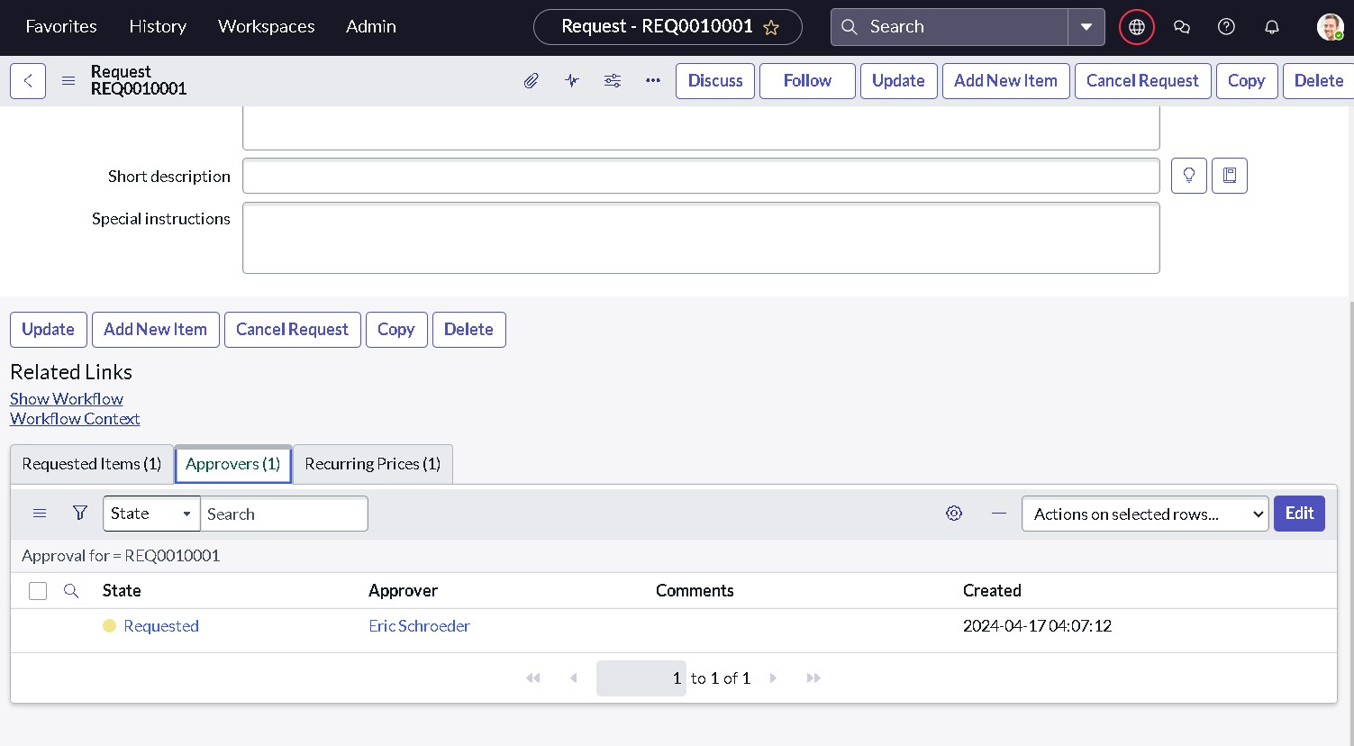

Step 5 – Verify Catalog Task
- Scroll down to the Catalog Tasks section.
- Open the Catalog Task record.
- Check the updated Status.
- Check the Short Description.
- Check the Assigned Group.
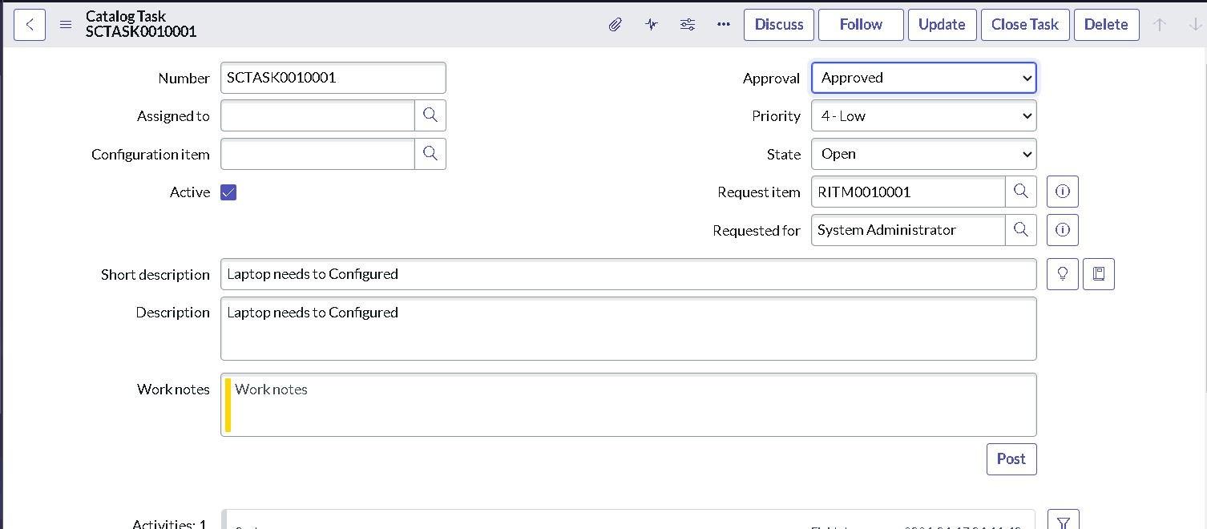

3. Demonstration Result
The demonstration verifies that the Standard Laptop procurement process is automated using ServiceNow Flow Designer.
The Catalog Task is generated with the required details and assigned to the Hardware group for configuration.

4. Final Outcome
The automated workflow helps to:
- Reduce manual intervention.
- Reduce user waiting time.
- Ensure timely laptop configuration.
- Optimize resource allocation.
- Improve efficiency in IT procurement.

